Your Band  
NEWSLETTER

January , 2018

# 

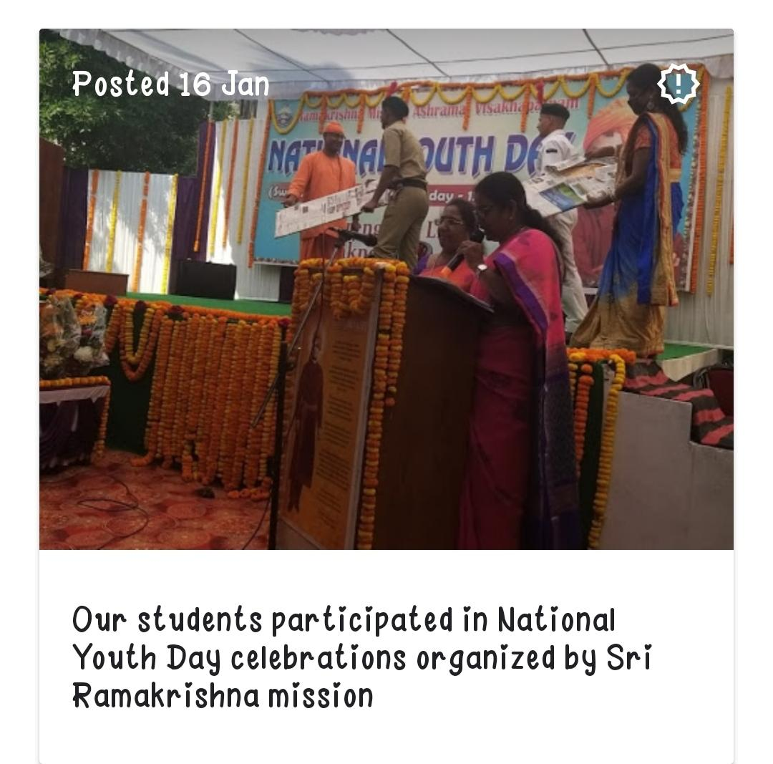

## National Youth Day- Ramakrishna mission

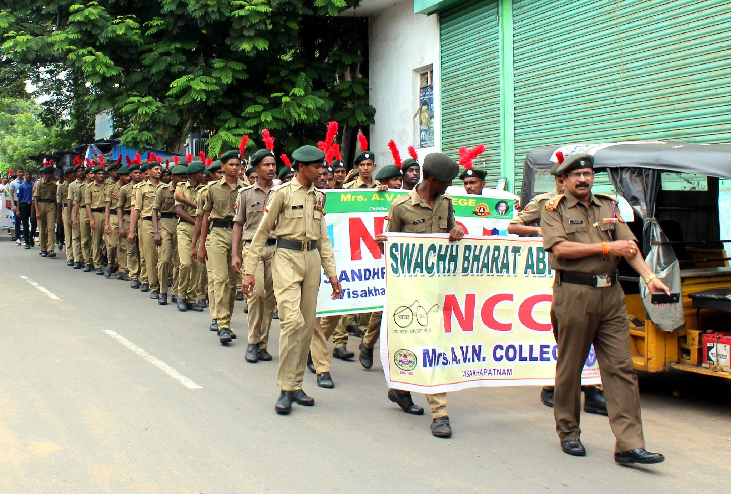

Swach Bharat Abhiyan

National Voters Day

